**LAB 08**

**NORMAL DISTRIBUTION**

**Aim: To analyze Normal Distribution in R**

**New-Term:**

1. **dnorm(): This function is used to calculate the probability density function (PDF) of a normal distribution. It calculates the probability of a random variable taking on a specific value. In the code, it is used to calculate the density values (y, y2, y1, y3) for the corresponding sequences (x, x2, x1, x3).**
2. **pnorm(): This function is used to calculate the cumulative distribution function (CDF) of a normal distribution. It calculates the probability of a random variable being less than or equal to a specific value. In the code, it is used to calculate the probabilities p1 and p2 for jobs taking less than 15 minutes and more than 25 minutes, respectively.**
3. **polygon(): This function is used to draw polygons on a plot. In the code, it is used to draw polygons with different colors (yellow, red, green) to represent specific ranges of values where the probability density is greater than 0. The polygons are created using the sequences x2, x1, and x3 along with their corresponding density values y2, y1, and y3.**

**Input:**

**#Question 1**

**#i) P(Z.1.89)**

**#ii)P(-1.97<Z<0.86)**

**#Generating the data**

**x = seq(0,40)**

**#This line creates a sequence of numbers from 0 to 40.**

**y = dnorm(x,mean=20,sd=5)**

**#This line finds the density function of x, which is the probability of x taking on a certain value.**

**plot(x,y,type='l')**

**#This line plots the normal distribution curve.**

**# Proportion of jobs that take less than 15**

**p1 = pnorm(15,mean=20,sd=5)**

**#This line calculates the probability of a job taking less than 15 minutes.**

**p1**

**#This line prints the value of p1.**

**x2 = seq(0,15)**

**#This line creates a sequence of numbers from 0 to 15.**

**y2 = dnorm(x2,mean=20,sd=5)**

**#This line finds the density function of x2, which is the probability of x2 taking on a certain value.**

**y2**

**#This line prints the values of y2.**

**polygon(c(0,x2,15),c(0,y2,0),col='yellow')**

**#This line plots a yellow polygon over the range of x2 values where the probability of x2 taking on a certain value is greater than 0.**

**#Proportion of jobs that take more than 25 mil**

**p2 = pnorm(40,mean=20,sd=5)-pnorm(25,mean=20,sd=5)**

**#This line calculates the probability of a job taking more than 25 minutes.**

**p2**

**#This line prints the value of p2.**

**x1 = seq(25,40)**

**#This line creates a sequence of numbers from 25 to 40.**

**y1 = dnorm(x1,mean=20,sd=5)**

**#This line finds the density function of x1, which is the probability of x1 taking on a certain value.**

**y1**

**#This line prints the values of y1.**

**polygon(c(25,x1,40),c(0,y1,0),col='red')**

**#This line plots a red polygon over the range of x1 values where the probability of x1 taking on a certain value is greater than 0.**

**#Proportion of jobs that take more than 15 & less than 25**

**x3 = seq(15,25)**

**#This line creates a sequence of numbers from 15 to 25.**

**y3 = dnorm(x3,mean=20,sd=5)**

**#This line finds the density function of x3, which is the probability of x3 taking on a certain value.**

**y3**

**#This line prints the values of y3.**

**polygon(c(15,x3,25),c(0,y3,0),col='green')**

**#This line plots a green polygon over the range of x3 values where the probability of x3 taking on a certain value is greater than 0.**

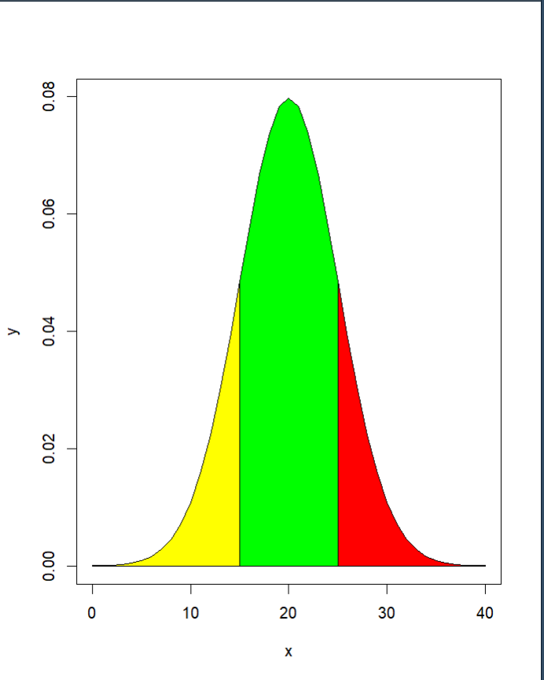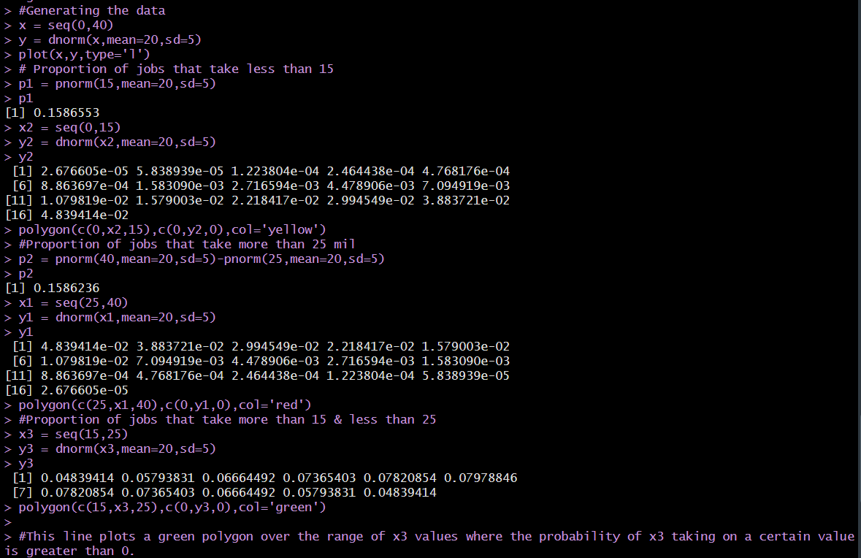**OUTPUT:**

**Inference:  
Variance calculated using weighted mean function and found normal distribution values for different ranges of a.**

**\*\*\*\*\*\*\*\*\*\*\*\*\*\*\*\*\*\*\*\*\*\*\*\*\*\***